**ASSIGNMENT 2:**

STUDENT TABLE:

CREATE:

create table student(stud_id number,stud_name varchar(20),stud_course varchar(20),stud_CGP number);

INSERT:

insert into student values(001,'aishu','AIDS',95);

insert into student values(002,'keerthi','ECE',93);

insert into student values(002,'deepka','AIML',96);

SELECT:

select*from student_info;

ALTER:

alter table student add stud_year number;

UPDATE:

update student set stud_year=2 where stud_id=002;

TABLE:

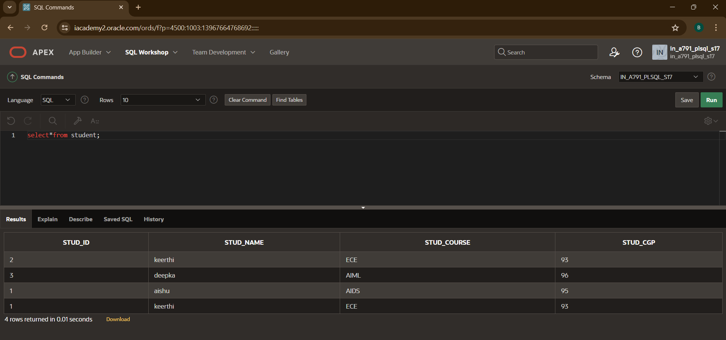

EMPLOYEE TABLE:

CREATE:

create table employee(emp_id number,emp_name varchar(20),emp_depat varchar(20),salary number);

INSERT:

insert into employee values(119,'kaveya','IT',95000);

insert into employee values(120,'Hasin','HR',960000);

insert into employee values(121,'lavanya','HR',76000);

SELECT:

select*from employee_info;

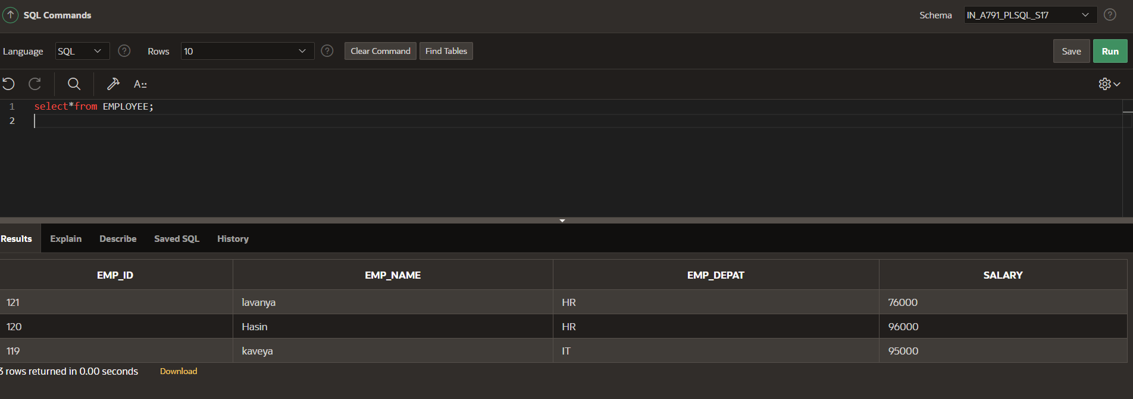

UPDATE:

update employee set salary=96000 where emp_id=120;

TRUNCATE:

truncate TABLE EMPLOYEE;

select*from EMPLOYEE;

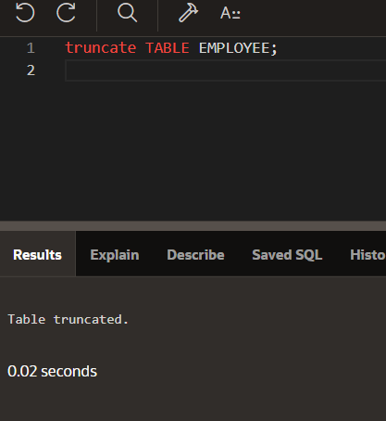

SUM:

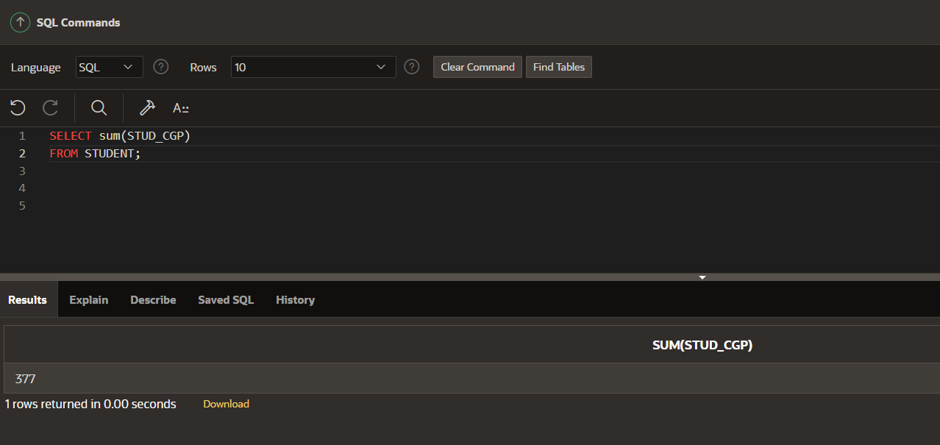

ORDER BY:

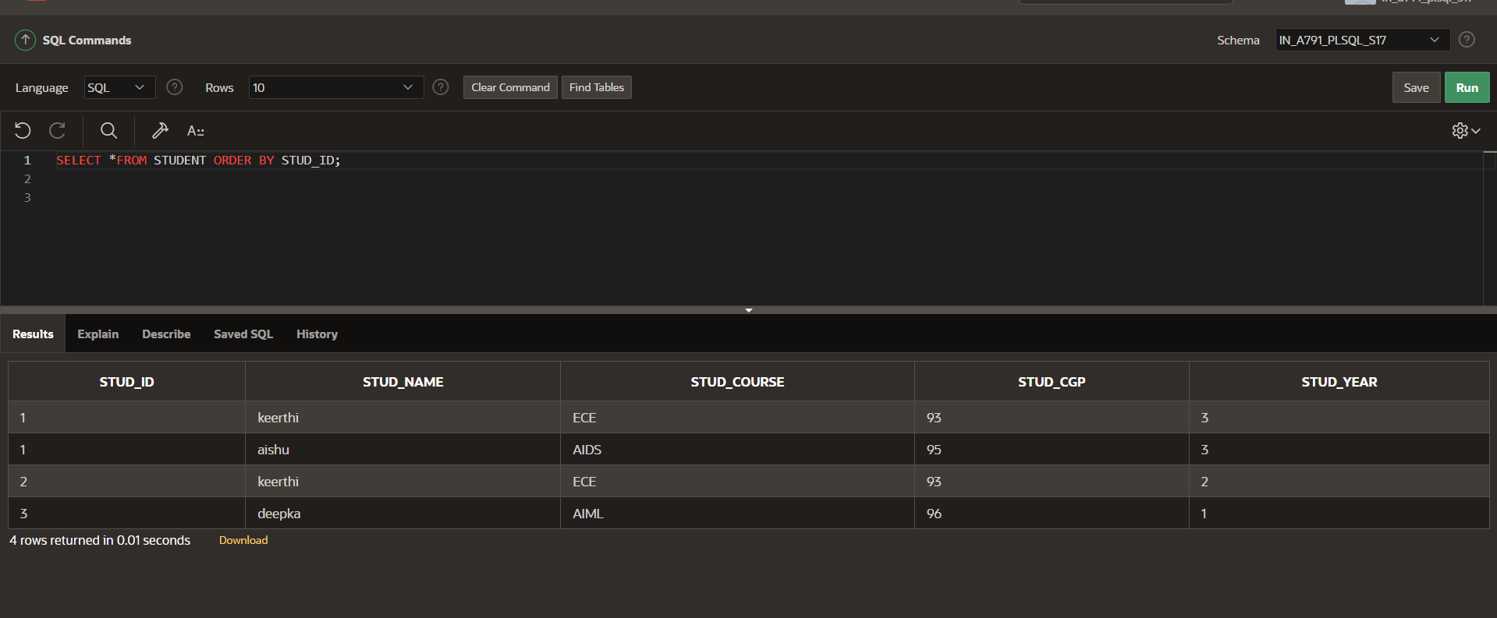

MAX :

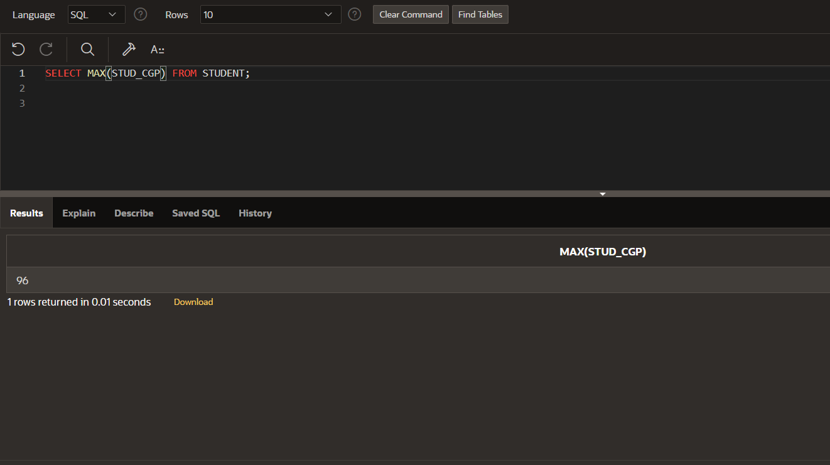

MIN:

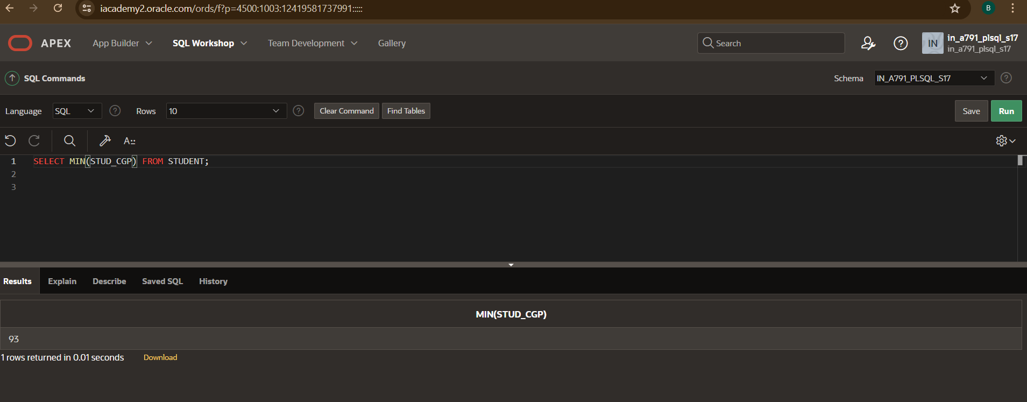

AVERAGE:

